**Steps to verify after packaging the installer ( 6 steps)**

Once you package the installer with the updated version, install it in your PC without uninstalling the existing one and please make sure to test the following without any fail.

**1) Previous installer should be uninstalled ‘automatically’ while installing the new version without any issues.**

2**) Check the murataStudio version in Programs and Features as well as in the About history of application . Both should belong to same version.**

Eg:

1. Programs and Features version should be : 0.49.0
2. About of murata Studio application : 0.49.0.0

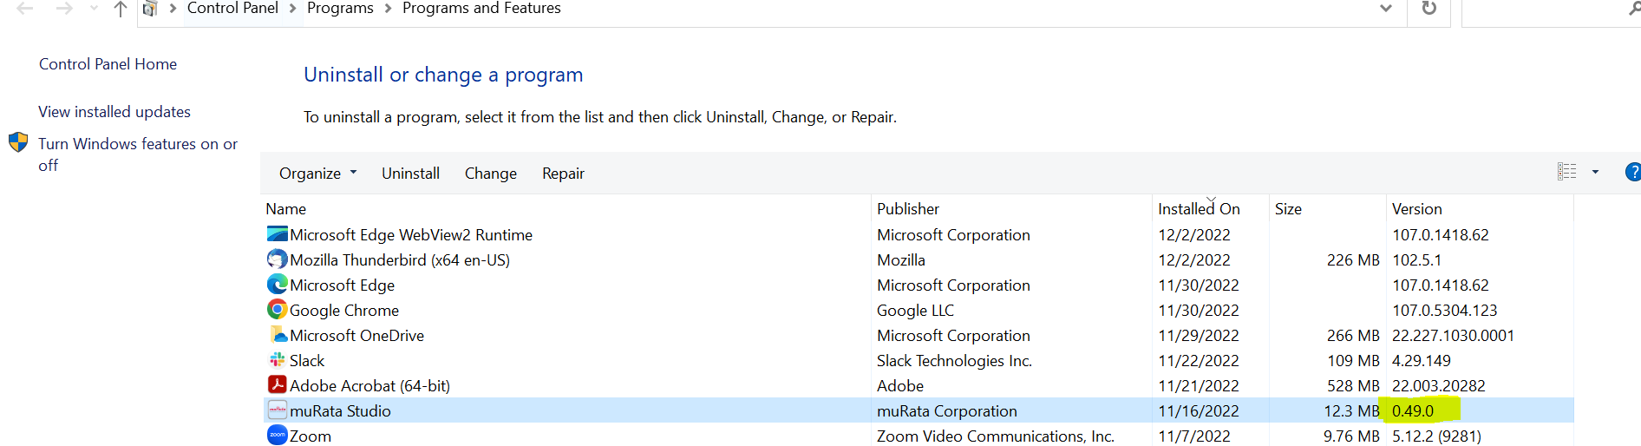

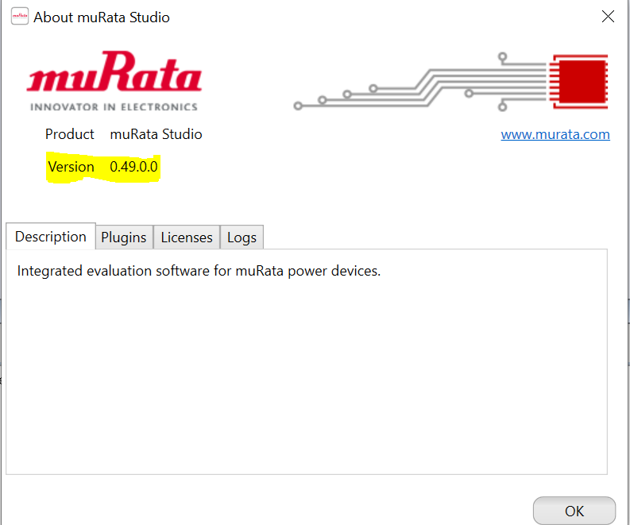

**3) Open the installed version of murataStudio application and verify the code changes are updated in the applications by testing the changes done.**

**4) Verify the installer Plugin dll’s are ‘latest’ by opening the installer folder in the path with the dll’s in the Release folder of the project/sln and check whether both has same timestamps( Date modified ).**

**Paths to verify are:**

* C:\Program Files (x86)\muRata Corporation\muRata Studio\Plugins.
* D:\Official\Psemi\muratastudio\Apps\muRata\bin\Release\Plugins.

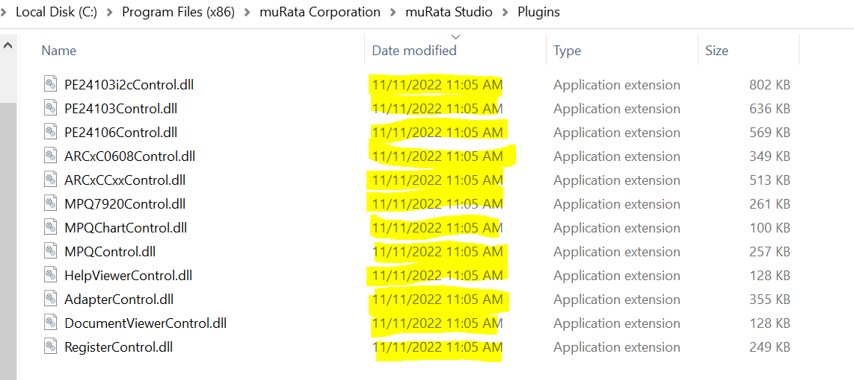

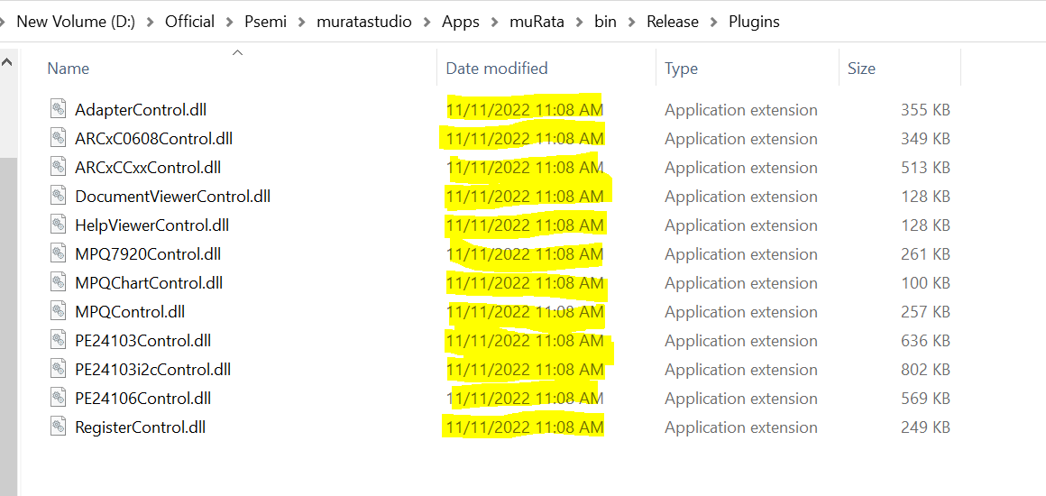

**5) Verify the installer .adz files( Devices) are ‘latest’ by opening the installer folder in the path with the dll’s in the Release folder of the project/sln and check whether both has same timestamps( Date modified ).**

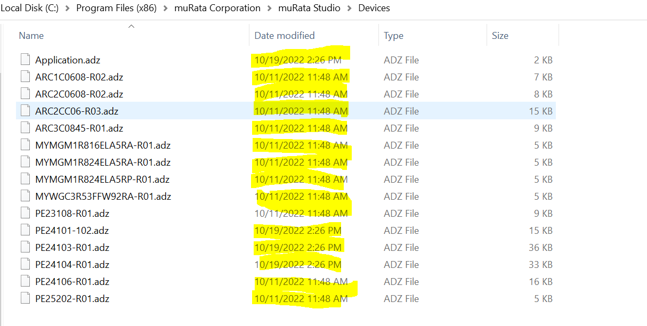

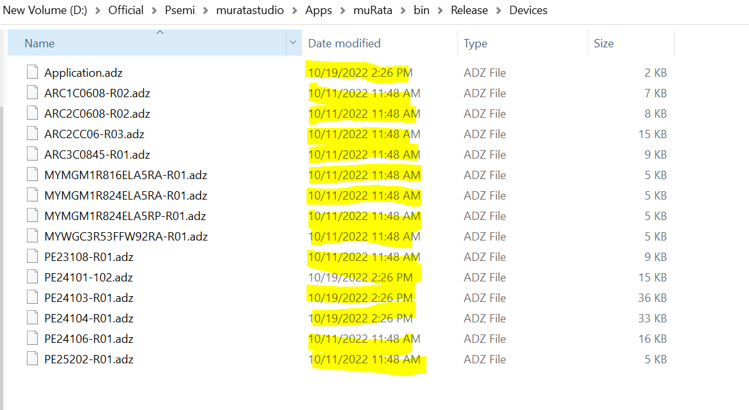

**6) Verify the installer.dll files( Project ) are ‘latest’ by opening the installer folder in the path with the dll’s in the Release folder of the project/sln and check whether both has same timestamps( Date modified ).**



